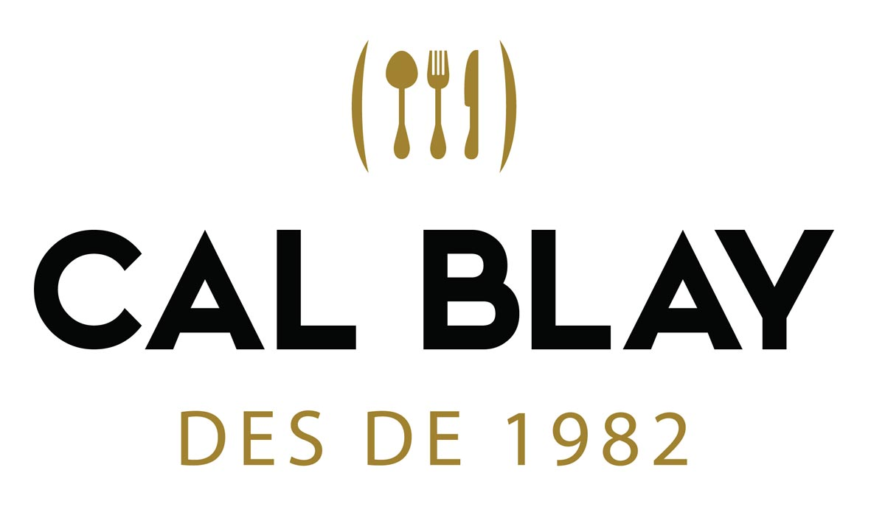
Wedding Information · 2026
CAMILA & RAYAN Upd. 16/06/2026
COORDINATOR: Laia
IN-HOUSE: Laia
MENU: Cal Blay 2

MENU TASTING DECO PACK: 2
Menu tasting day: Feb 21, 2026 Time: 12:30h MC + 14:30h CBO Pax: 5 → included
2nd part of menu tasting for:
· 2 pax if the wedding has 60 to 80 guests
· 4 pax if the wedding has 81 to 120 guests
· 6 pax if the wedding has minimum 120 guests
Note: extra tasting menus have an extra cost of 65€/person + VAT.

WEDDING INFORMATION
Wedding day: Friday, July 3rd, 2026
Wedding venue: Clos La Plana (Sant Pere de Ribes)
CEREMONY IN THE VENUE:
The couple can arrive 3 hours before the welcome drink or ceremony to make up, dress up…
Extra hour to open the venue: 150€ + VAT / hour
Bride’s arrival time: 14h - SUITE
Groom’s arrival time: 14h – CABERNET
SALA ROURE for friends
Arrival time: 17:00h – Welcome drink
Time / space ceremony: 17:30h | Tower
Time / space appetizer: 18:30h | Bougainvillea’s patio
Entrance + first dance: 20:30h to 21:30h
Space for lunch or dinner: 21:30h | Garden
Space for dance: 23:30h | Banquet Hall – until 02:00h
DJ: Marian – 690 626 438 – info@djmarian.com

TABLES |  | TOTAL | DISTRIBUTION
Round tables: | X | 8
Large tables: | X | 3 | 1x 18 pax + 2x 24 pax
DECO PACK 1: The banquet can be set up with 100% round tables, or with a combination of round tables and wooden long tables, with a maximum of 50% wooden long tables. If you wish to have 100% wooden long tables, with or without table runners, a supplement of €3 per person + VAT.
GUESTS | MENU TastING | 15 DAYS MEETING | 6 DAYS before
Adult menu | 150 | 128
Children menu (up to 5 y.o) | 7 | 7
Children menu (6-13 y.o)
Extra/staff menu | 7 | 7
Baby high chairs

CEREMONY ft. Loving the flowers
 | Civil [ X ] Religious [ ]
 | Space: TOWER |  | Arrival time: 17:00h | Ceremony time: 17:30h
X | 130 chairs included for the guests – ONLY CHAIRS

CIVIL CEREMONY EXTRAS:
X | Welcome drink before the ceremony: not included → Price: 3,0€/p.p. (water, lemonade and beers)

OFFICIANT – CB HAS SENT CONTACTS
 | Cal Blay provide the contact to the couple |  |  | Couple’s contact

OBSERVATIONS & OTHERS FOR THE CEREMONY:
Price for basic ceremony set up: 650€ + VAT

INSTRUCTIONS DOCUMENT – NO

MENU CARD + Nº TABLE + NAME CARD
COUPLE’S NAMES:
LOGO: yes [ X ] (the couple must send the logo in vectorial, illustration or HD PDF) Received @040626
LANGUAGE (appetizer max. 1): ENGLISH
LANGUAGE (banquet max. 2): ENGLISH + SPANISH
MENU CARD for the banquet
 | PACKS | MODEL | NAME | PAPER
X | 1, 2, 3 | Nº. 2 | 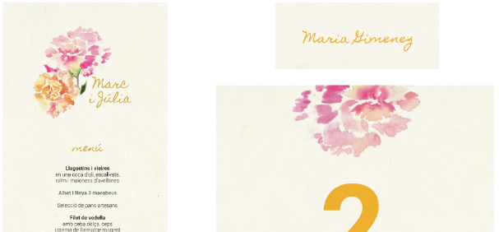  WATERCOLOR FLOWERS | Beige

NAME CARd – YES

Nº TABLES FOR THE BANQUET
X | STANDARD TABLE NUMBER → Cal Blay prints it and provides the support (LOG)

TABLES DISTRIBUTION & LISTS OF GUESTS
X | Provided by Cal Blay

SEATING STRUCTURE
X | Cal Blay venues: Provided by Cal Blay - Bookshelf

table decorations / floral centerpieces

OBSERVATIONS AND OTHER TABLE DECORATIONS
Discount applied – PROVIDED BY LOVING THE FLOWERS

TABLEWARE
TRADITIONAL MENU - BANQUET
X | Round tables with tablecloth: STONE
X | Large wooden tables (0,84 x 1,83) with tablecloth way: STONE
X | WHITE napkin
X | Cutlery CB
X | Glassware CB
X | Water glass: BELEM
X | Under-plate: WICKER
X | Chair: CROSSBACK

OBSERVATIONS TABLEWARE / FURNITURE
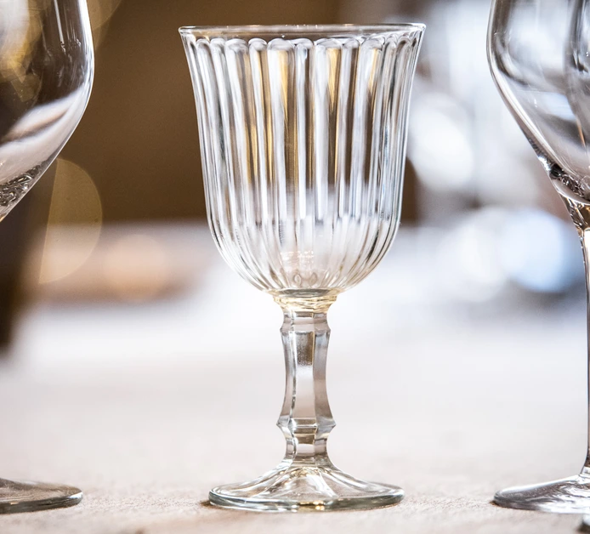
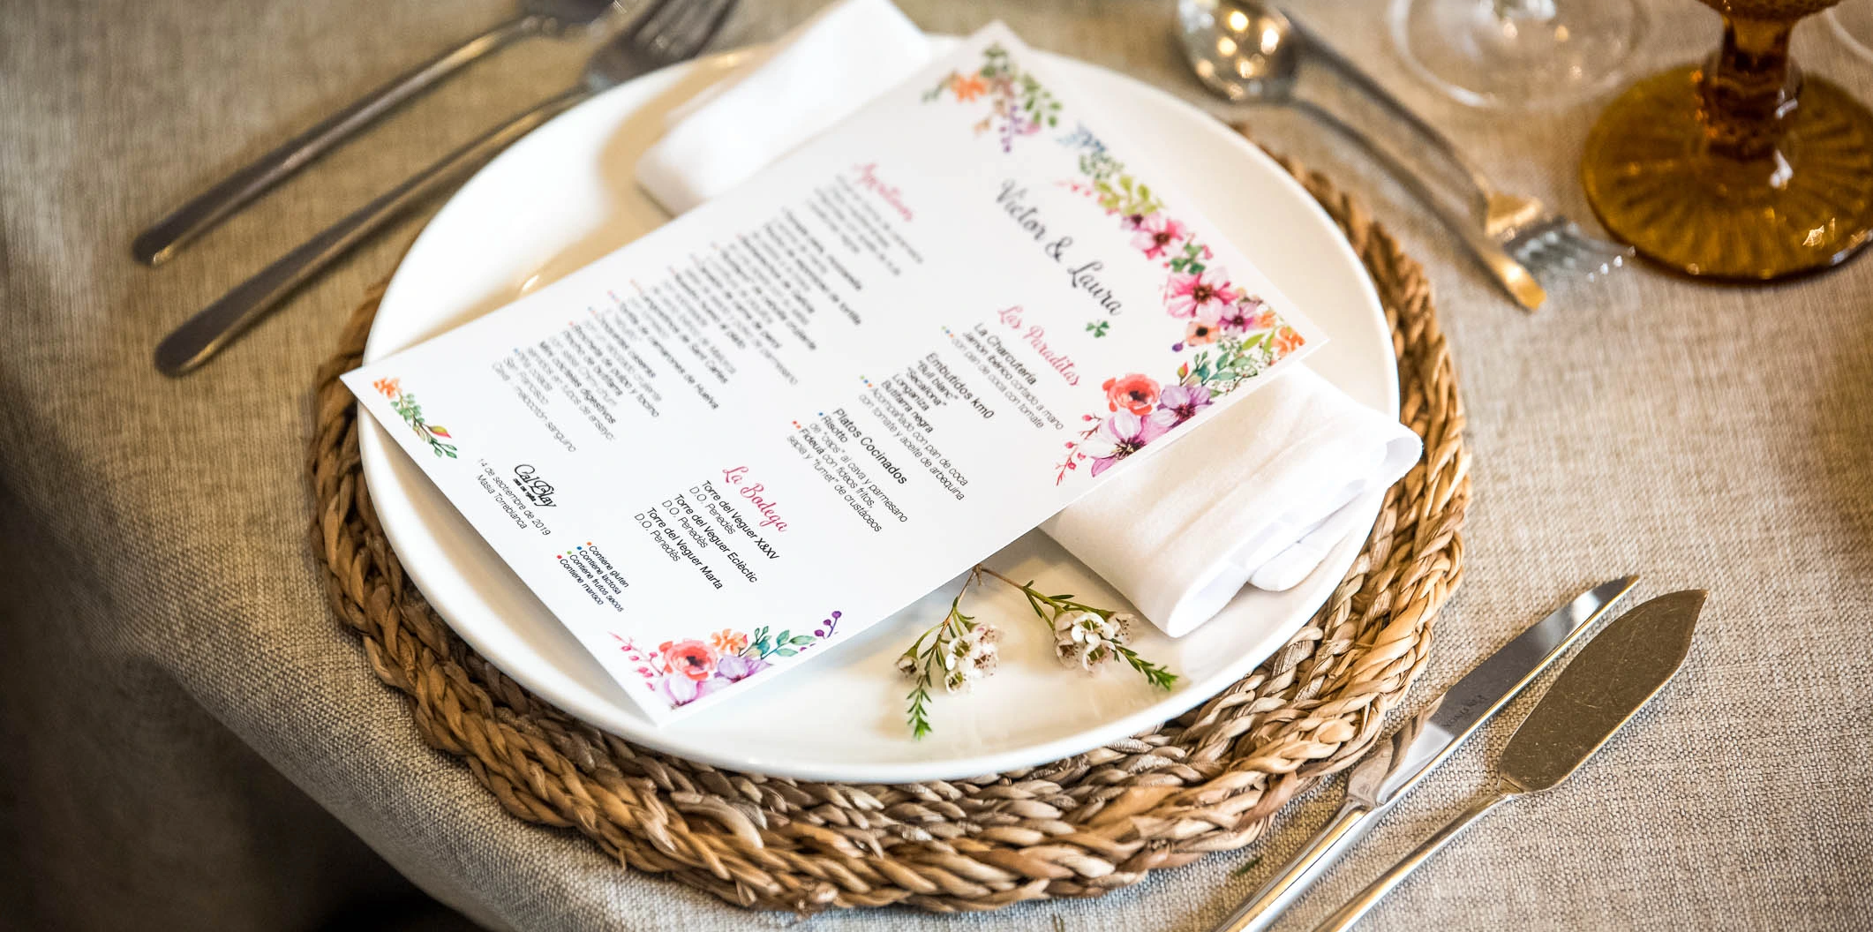
BANQUET IS TAKING PLACE IN THE GARDEN +6€ / p.p.

PROVIDE LOW TABLES FOR THE APPETIZER

PROVIDE HIGH AND LOW TABLES FOR THE PARTY

WAITERS UNIFORM
X | Beige short apron + beige braces

GASTRONOMY
Nºpax | Special menus |  |  | Late night snacks
 | Gluten free |  | X | Mini sandwiches (cheese, guacamole and hummus)
 | Vegetarians / vegans 100% |  | X | Fresh fruit
 | Lactose intolerant |  |  | Candy Bar → Price: 2,50€/pax (minimum 70 pax)
 | Seafood allergic |  |  | Nutella mini croissants i cream xuxos → Price 3€/pax

OBSERVATIONS ALLERGIES / INTOLERANCES
Please inform us of any food allergies or intolerances as soon as possible (at least 15 days before the celebration), for correct preparation and coordination with our suppliers and chefs. Otherwise, we will not be able to guarantee this service.

Aperitif for children
For celebrations with more than 5-6 children, we inform you about the option of an appetizer only for them:
Mediterranean chips + Olives + Fuet + Manchego cheese + Homemade croquettes

Price: 10€/child + VAT.
We will set up a table just for them during the aperitif, they will be served and so their parents will also have more control over them.
From previous experience, this is an option that works very well when there are more than 5-6 children, especially when there is no lack of food from the snacks provided for the adults (snacks, appetizers and buffets).
Cal Blay always carries the correct grammage of food for the expected number of adults, but when there are more than 6 children, we can't take the risk of missing food from the adults.
Note: it is only a recommendation so that everyone is satisfied during the snack and to ensure a good service.

CHILDREN’S / TEENAGER’S MENU
Combo dish | Macaroni Bolognese + chicken sticks + fries + ketchup – NO PORK
Dessert | Ice cream

WEDDING CAKE ITALIAN-STYLE WEDDING CAKE (1 flavour – cream)
X | THEIR OWN, with trolley (APORTAN ELLOS) |  | X | NO

DESSERTT BUFFET CAVA PYRAMID
X | NO |  | X | NO

GASTRONOMY OBSERVATIONS
SERVICE PAUSE FOR BANQUET ENTRANCE AND FIRST DANCE → 350€ + VAT

CELLAR
White wine | Albet i Noya Icones Xarel·lo-Macabeu-Chardonnay | D.O. Penedès
Red wine | Fra Guerau Cabernet Sauvignon-Merlot-Garnatxa-Syrah | D.O. Montsant
Sparkling wine | Llopart Brut Nature Reserva Xarel·lo-Macabeu-Parellada | Corpinnat

LIQUOR AND DRINKS BAR FOR THE PARTY
Liquors for coffees
Special liquors for coffees: | STANDARD
Drinks bar for the party
Duration of drinks bar for the party: | 2h30min (duration according to accepted proposal)
Special liquors for the party: | STANDARD

Special buffets for party drinks bar |  | Price
“Mojitos”
Various Cocktails

Extra hour for party drinks bar:
 | YES |  |  | NO |  | Price: | 500€/hour + VAT | (to be decided in-situ)

Observations liquors and drinks bar
Rayan will bring bottle/s for himself maybe some Colombian drinks too – TBC
Rayan traerá licor para él, quizás algo de bebida colombiana también

BUSES DEPARTURES – NO

CONTACT EXTERNAL PROVIDORS
EXTERNAL PROVIDOR | CONTACT (NOME + PHONE/EMAIL) | @ INSTAGRAM
Florist | Loving the Flowers

DETAILS FOR GUESTS
EVERYBODY: coffee mug + coffee

OTHERS / DECORATIONS EXTRAS
X | Desk with 50 cones (choose an option) | 100% petals → price: 150€ | NARANJA, ROSA Y FUCSIA

INTERNAL NOTES MAÎTRE
WELCOME
Welcome drink at the end of the orange trees patio. The family will be aligned greeting guests at the beginning of the patio.
Rayan will be at the welcome as well

CEREMONY
130 chairs for the guests. NO DECO → Loving the Flowers
Move the deco (LTF) to the party
ENTRANCES: Rayan and his mum | Rayan’s dad | Rayan’s brother | Camila’s Brother (1 song)
Camila and his parents → pasillo nupcial más ancho
Fans on the seats and umbrellas on the baskets
APPETIZER
Eldest table during appetizer
We will need lower tables for the appetizer – number to be confirmed
Move the deco (LTF) to the party
Starting food service without Camila and Rayan (30+ min pictures)
45min band during the appetizer, starting after the entrance, once they finish playing, they will relocate to the banquet area
Entrance with a song from the band
CONFIRMAR NUMERO MESAS ALTAS PARA LOVING!!! + ENVIAR REFERENCIAS BARRA
SERVICE PAUSE FOR ENTRANCE AND FIRST DANCE
Drinks bar will be still running.
First dance = DJ song → Camila needs to tie her tail
45 min band show
PRINTING A LIST OF THE REFERENCES FOR BOTH BARS (APPETIZER AND SERVICE PAUSE)

BANQUET
They will bring their own cake – FORM SENT ON @16/03/2026
Song for the cake, no words, cake served as a late snack
Camila changes her dress before party – Rayan changes shirt as well – Ready for party!

PARTY
Shorten banquet hall.
Set up high and low tables for the party.
Deco from ceremony and appetizer.
DJ starts party without the couple and then they come in

LAST MEETING – 15 DAYS
Gifts / SPEECHES
1. | Abed Saad 1x speech (less than 3 min) – before main dish
2. | Luis Quesada 1x speech (less than 3 min) – before main dish

additional information
The revised menu price (169,50€ + VAT) is guaranteed for a minimum of 120 adult menus.
Price variations according to the number of adult menus:
For less than 120 adult menus +19€.
For less than 100 adult menus +21€.
For less than 80 adult menus +25€.
For less than 70 adult menus please ask for supplement
* The supplement will be counted for the total number of adult menus, and from adult nº. 1
CONFIRMATION OF FINAL NUMBER OF GUESTS: Deadline to send LIST OF TABLES, LIST OF OBSERVATIONS, DISTRIBUTION OF TABLES… is from Friday 19 to Sunday 21 (two weekends before the wedding).
Monday 22 morning we will close the project and the final numbers of guests. WE WILL NOT ACCEPT GUEST CANCELLATIONS FROM MONDAY AT 12 NOON.
LAST MEETING 3/4 WEEKS BEFORE THE WEDDING: June 1st, 2026

ACCOMMODATION – NO
They arrive to spain on the 1st, arrange best day/time to bring all the stuff

